VIETNAM NATIONAL UNIVERSITY OF HO CHI MINH CITY INTERNATIONAL UNIVERSITY
SCHOOL OF COMPUTER SCIENCE AND ENGINEERING



FINAL REPORT
Website Project
Course: Web Application
Student Name: Trương Võ Hải Âu

Table of content
1. INTRODUCTION 3
1.1. The product’s information 3
1.2. WORK BREAKDOWN STRUCTURE 3
2. OBJECTIVES – SCOPE 6
2.1. Objectives 6
2.2. Scope 6
3. SYSTEM REQUIREMENTS ANALYSIS DESIGN 7
3.1. Goal 7
3.2. Scope 7
3.3. Stakeholders & Actors 8
3.4. Assumptions & Constraints 8
3.5. Functional Requirements (FR) 8
3.6. Non-functional Requirements (NFR) 10
3.7. Data Model 10
4. TECHNOLOGIES USED 12
4.1. Frontend (Interface) 12
4.2. Backend & Database 12
4.3. Other Tools & Libraries 12
5. Core Flows 12
Flow A — Search -> View -> Add to Cart 12
Flow B — Cart -> Checkout -> Create Order 12
Flow C — Orders history 12
6. DETAILED FUNCTIONS & APPLIED ALGORITHMS 13
6.1 Sorting (Price Sorting) 13
6.2 Fuzzy Search (Search Tolerance) 13
6.3 Autocomplete (Search Suggestions) 13
6.4 Price-Range Filter (Binary Search) 13
6.5 Product Recommendations (Similarity Ranking) 13
6.6 Budget Optimizer (0/1 Knapsack) 13
6.7 Auto-Grouping (K-Means Clustering) 14
6.8 Recently Viewed Products (Stack) 14
6.9 Shipping Path Graph (Dijkstra) 14
7. EVALUATION – PROS & CONS 14
7.1. Pros 14
7.2. Cons 15
8. FUTURE DEVELOPMENT 15
9. CONCLUSION 16
10. REFERENCES 16

INTRODUCTION

The product’s information
In the current era of digitalization, E-commerce has become an indispensable part of daily life. The increasing demand for online shopping requires sales websites to not only have an attractive interface but also be intelligent, have fast processing speeds, and provide the best User Experience (UX).
However, many basic sales websites today still face limitations in supporting users to search for products when there are spelling errors, or lack intelligent suggestion features based on the customer's budget.
Stemming from that reality, the project "Building a Fashion E-commerce Website (Mixer Shop)" was implemented not only to create a fully functional online shopping channel but also to serve as a place to experiment and apply Data Structures and Algorithms (DSA) into practice to solve user experience optimization problems such as: fuzzy search, keyword suggestions (autocomplete), and budget-based shopping optimization.

1.2. WORK BREAKDOWN STRUCTURE
The structure of our project can be expressed:

The tasks for the Customer’s product viewing is described:
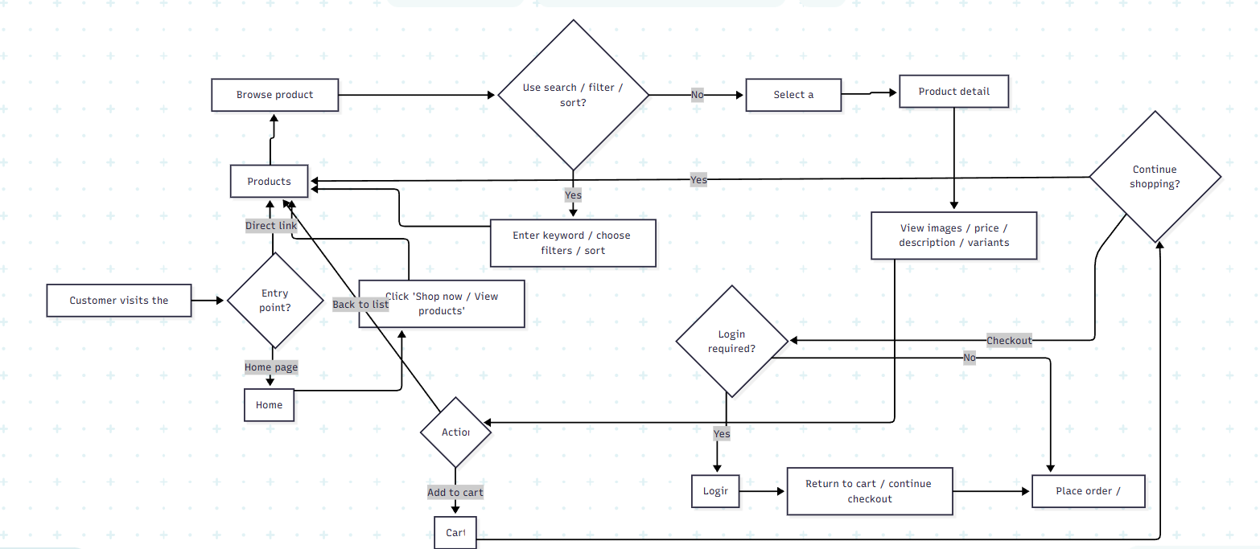
The tasks for the Product Searching and Comparison is described:
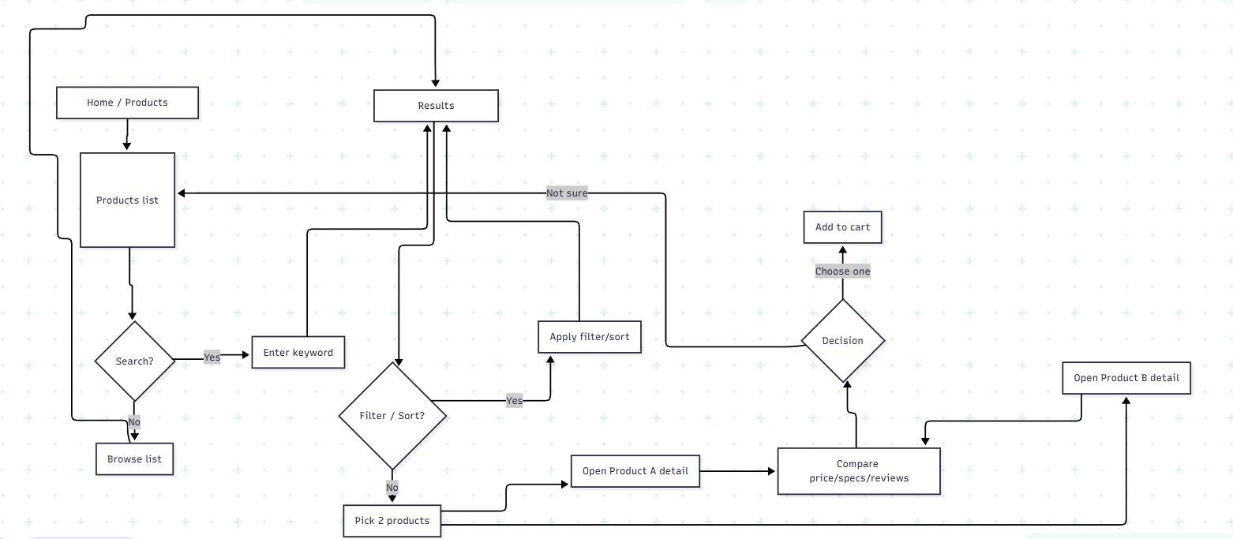
The tasks for the System Login is described:
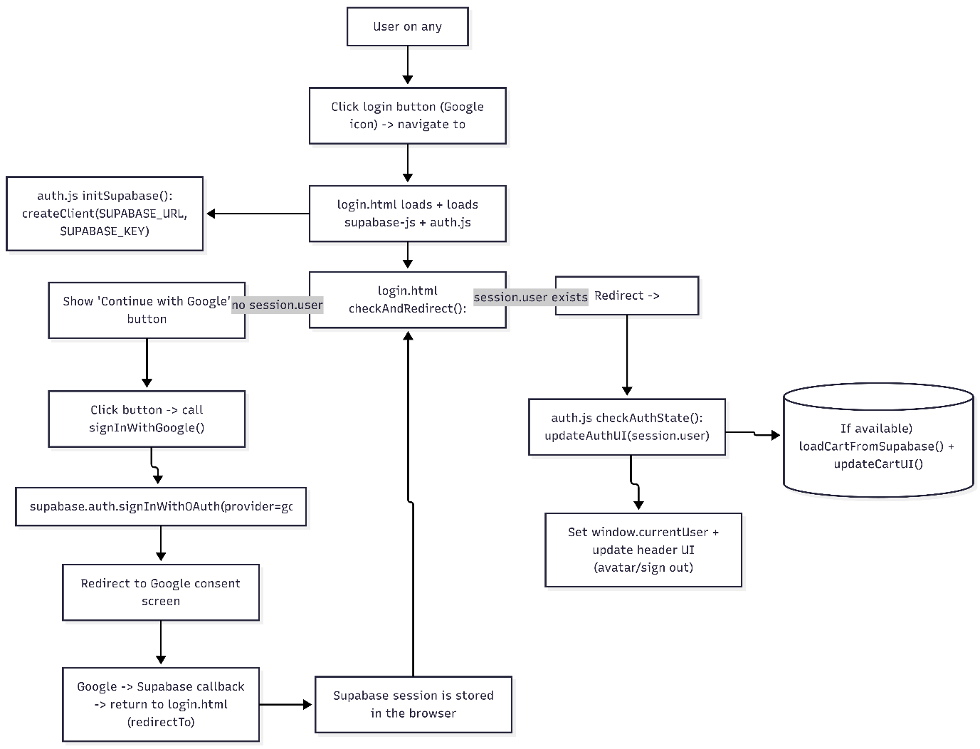
The tasks for the Online Buying Transaction is described :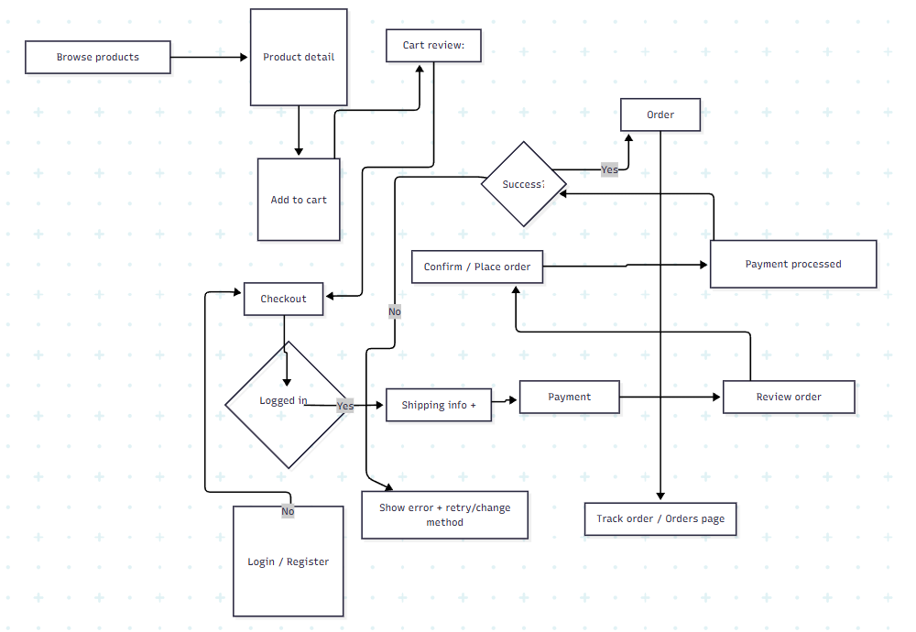

2. OBJECTIVES – SCOPE

2.1. Objectives
- Build a complete website: Allow users to view, search, select products, and manage orders.
- Apply Algorithms (DSA): Integrate algorithms such as Trie, Merge Sort, and Dynamic Programming to improve performance and intelligent features.
- Cloud Integration: Use Supabase for data storage and user authentication, ensuring synchronization and security.
- Modern Interface: Responsive design, friendly to all devices.

2.2. Scope
- Client Side:
  - Register/Login (Google OAuth).
  - View product list, product details.
  - Smart Search (Suggestions, typo correction).
  - Cart Management (Local & Cloud storage).
  - "Budget Shopping" feature (Budget Optimizer).
  - View order history, personal profile.
- Data: Focus on fashion items (Clothing, accessories).

3. SYSTEM REQUIREMENTS ANALYSIS DESIGN

3.1. Goal
- Allow customers to browse/search products, view details, add to cart, checkout, and review order history.
- Provide “smart discovery” (autocomplete, price sorting, price-range filtering, algorithm-based recommendations) within a client-side scope.
- Run without a backend (fallback dataset + localStorage) and also run with a backend (Supabase) when configured.

3.2. Scope
In scope
- Product listing page (PLP) + product detail page (PDP)
- Search + autocomplete + collection filters (men/women/new/sale) + price sorting
- Price-range filtering (min/max)
- Cart: add/remove/update quantity + size
- Checkout modal with shipping info + payment method selection (COD/BANK)
- Orders: list orders + view order details (modal)
- Google login via Supabase (gating: login required for add-to-cart and viewing orders)
Out of scope (for this version)
- Real online payment gateway integration (Stripe/MoMo/VNPay)
- Admin/backoffice product & order management
- Complex promotion/voucher/loyalty features
- A dedicated “Compare products” page (comparison is described as a basic user behavior: opening two PDP tabs)

3.3. Stakeholders & Actors
- Guest: not logged in (browse/search/view products)
- Customer (logged-in): logged in (cart, checkout, orders, profile)
- System: client-side app + optional Supabase

3.4. Assumptions & Constraints
- The app runs as a static site; the browser performs most logic.
- When Supabase is available, it uses tables: products, orders, user_carts.
- If Supabase is unavailable/misconfigured, the app uses fallbackData and simulates order confirmation (no persistent order storage).
- Cart state is stored in localStorage under key mixerCart.
- Product views are tracked in localStorage under key productViews and optionally in products.view_count on Supabase.

3.5. Functional Requirements (FR)
FR-01 — Browse products (PLP)
- Display products in a grid layout.
- Each card shows: image, name, price, category tag, badges (NEW/SALE), view count.
- Clicking a card navigates to product-detail.html?id={id}.
FR-02 — Search & Autocomplete
- Search input supports Enter to navigate to: products.html?search={keyword}.
- Trie autocomplete displays up to 5 suggestions when input length >= 2.
- Clicking a suggestion navigates directly to PDP.
FR-03 — Filter by collection type
- Support type query on PLP: men, women, new, sale, all (default behaves like “Shop All”).
- type can be combined with search.
FR-04 — Sort by price
- Support price sorting ascending/descending.
- Re-render PLP when sort selection changes.
FR-05 — Filter by price range (min/max)
- Users enter min and max then press “Go”.
- The result is a list filtered by the selected price range.
FR-06 — Smart discovery (DSA / algorithms)
- Auto-group (KMeans) can group products for discovery.
- Budget optimizer suggests a set of products that fit a user-entered budget.
- Trending keywords are displayed.
FR-07 — Product detail (PDP)
- PDP reads product id from the query string.
- Show: image, name, price, description, category, badges.
- Allow size selection (S/M/L/XL/XXL) and quantity adjustment (+/-).
- Show related/recommended products.
FR-08 — Track product views
- When a user clicks a product card (PLP), increment view count:
  - Local: localStorage.productViews[productId]++
  - Supabase (optional): update products.view_count
FR-09 — Authentication (Google via Supabase)
- Support Google OAuth login.
- On successful login: Show user dropdown (profile, orders, logout), load cart from Supabase (if available) and sync into localStorage.
- On logout: Clear mixerCart locally, update UI and redirect to home.
FR-10 — Add to cart (login required)
- If not logged in: show a toast and redirect to login.
- If logged in: Add item {id, quantity, size} to mixerCart. If the same id + size exists, increase quantity. Persist to Supabase user_carts (optional).
FR-11 — Cart management
- Cart page displays items and supports: Increase/decrease quantity (minimum 1), change size (if changing to a size that already exists for the same product, merge quantities), remove an item.
- Compute subtotal/total and display it.
FR-12 — Checkout (modal)
- Checkout can only open when cart is not empty.
- Prefill name/phone/address from user metadata if available.
- Inputs: Full name, phone, address, payment method (COD/BANK).
- On confirm: Create an order in Supabase table orders (if available). If Supabase is not available: show a “simulation confirmed” message. Clear cart in localStorage and clear user_carts.
FR-13 — Orders history
- Orders page requires login; otherwise redirect to login.
- Fetch orders by user_id, newest first.
- Display order list and count. Order details modal shows customer info, payment, status, items, and total.
- If the orders table does not exist: show mock orders.

3.6. Non-functional Requirements (NFR)
- NFR-01 — Usability: Clear navigation between Home/PLP/PDP/Cart/Orders. Provide toast feedback for success/error/info. Responsive layout (mobile friendly).
- NFR-02 — Performance: PLP should render quickly for dozens to a few hundred items. Autocomplete should respond in < 200ms for a small dataset.
- NFR-03 — Reliability / Offline-friendly: If Supabase is down/unavailable: core browsing still works with fallback data. Cart persists in localStorage.
- NFR-04 — Security & Privacy (recommended): Avoid hard-coding Supabase keys in a production client. Validate checkout inputs (phone/address) and avoid XSS when rendering strings. Orders must be queried only for the current user.

3.7. Data Model
Entities
Product
- id: number
- name: string
- price: number
- image: string (url)
- category: 'men' | 'women' | string
- is_new: boolean
- is_sale: boolean
- description: string
- view_count: number
CartItem (local)
- id: number
- quantity: number
- size: string (default: 'M')
Order
- id: string | uuid
- user_id: string | uuid
- customer_name: string
- phone: string
- address: string
- payment_method: 'COD' | 'BANK' | string
- total_price: number
- items: OrderItem[]
- status: 'pending' | 'processing' | 'shipping' | 'delivered' | 'completed' | 'cancelled'
- created_at: timestamp
OrderItem
- product_id: number
- product_name: string
- product_image: string
- quantity: number
- price: number
UserCart (Supabase)
- user_id: uuid (PK)
- cart_data: json/text
- updated_at: timestamp

4. TECHNOLOGIES USED

4.1. Frontend (Interface)
- HTML5 / CSS3: Build structure and format the webpage.
- Tailwind CSS: CSS Framework for fast, modern, and responsive interface design.
- JavaScript (ES6+): Handle logic, DOM manipulation, and API calls.

4.2. Backend & Database
- Supabase: Backend-as-a-Service (BaaS) platform replacing Firebase.
  - PostgreSQL: Powerful relational database for storing products and orders.
  - Authentication: Manage user authentication (Google OAuth).
  - Storage: Store product images (if applicable).

4.3. Other Tools & Libraries
- FontAwesome: Icons for the interface.
- Google Fonts: Display fonts.
- Git/GitHub: Source code management.

5. Core Flows

Flow A — Search -> View -> Add to Cart
- User enters keyword in PLP or searches via input.
- User sees results and clicks a product card.
- System tracks view count and navigates to PDP.
- User selects size/qty.
- If logged in, item is added to cart; otherwise, redirect to login.

Flow B — Cart -> Checkout -> Create Order
- User opens Cart. If not empty, user opens checkout modal.
- User fills information and confirms.
- If Supabase is available, system inserts order; otherwise, shows simulation.
- System clears local and remote cart, then shows success.

Flow C — Orders history
- User visits Orders page (login required).
- System fetches orders by user_id.
- User views order list and clicks for details.

6. DETAILED FUNCTIONS & APPLIED ALGORITHMS
A special feature of the project is the application of DSA algorithms to specific functions:

6.1 Sorting (Price Sorting)
- Feature: Sort products by price (Low to High / High to Low).
- Algorithm: Merge Sort.
- Behavior: A stable sorting algorithm that ensures consistent results for products with identical prices.
- Complexity: O(nlogn) Time; O(n) Space.

6.2 Fuzzy Search (Search Tolerance)
- Feature: Search results accept minor typos for longer keywords.
- Algorithm: Levenshtein Edit Distance (Dynamic Programming).
- Behavior: Calculates the minimum number of edits to match a keyword to a product name. Acceptable distance is <= 3 for long words.
- Complexity: O(n . |k| . |name|) where k is keyword length.

6.3 Autocomplete (Search Suggestions)
- Feature: Instant suggestions as the user types (>= 2 characters).
- Data Structure: Trie (Prefix Tree).
- Behavior: Stores product tokens in a tree structure for ultra-fast prefix lookups.
- Complexity: Search is O(P + R) (P: prefix length, R: number of matches).

6.4 Price-Range Filter (Binary Search)
- Feature: Filter products within a specific [min, max] price interval.
- Algorithm: Binary Search on a sorted list.
- Behavior: Finds the lower and upper boundary indices efficiently without scanning the entire array.
- Complexity: O(log n) for boundary search.

6.5 Product Recommendations (Similarity Ranking)
- Feature: Show "Related Products" on the Product Detail Page (PDP).
- Algorithm: Jaccard Similarity.
- Behavior: Computes similarity scores based on token sets from names and categories to find the best matches.

6.6 Budget Optimizer (0/1 Knapsack)
- Feature: Suggests a set of items that maximize spending within a user's budget.
- Algorithm: Knapsack Problem (Dynamic Programming).
- Behavior: Builds a DP table to determine the optimal combination of products that do not exceed the budget limit.
- Complexity: O(n . W) where W is the budget.

6.7 Auto-Grouping (K-Means Clustering)
- Feature: Clusters products into Budget, Standard, and Premium groups.
- Algorithm: K-Means Clustering (1D on price).
- Behavior: Iteratively calculates centroids to group products by price proximity.

6.8 Recently Viewed Products (Stack)
- Feature: "Recently viewed" list displayed to the user.
- Data Structure: Bounded Stack.
- Behavior: Uses LIFO (Last-In, First-Out) logic, storing the last 5 unique products in localStorage.

6.9 Shipping Path Graph (Dijkstra)
- Feature: Estimate shipping distance/time between cities.
- Algorithm: Dijkstra’s Algorithm.
- Behavior: Finds the shortest path in a weighted graph representing city connections.

7. EVALUATION – PROS & CONS

7.1. Pros
    - Complete Shopping Journey
- The application provides a seamless, end-to-end user experience. The journey from Product Listing Page (PLP) to Product Detail Page (PDP), into the Cart, through a validated Checkout, and finally to Order History is fully functional.
- Backend Mode: Leverages Supabase for real-time data persistence and Google Authentication.
- Fallback Mode: Demonstrates the same flows using local simulation, ensuring the app is always "presentation-ready."
- Strong DSA Integration
- Unlike theoretical projects, MIXER connects Data Structures & Algorithms directly to UI actions:
- Search & Autocomplete: Uses a Trie (Prefix Tree) for instant suggestions and Levenshtein Distance for typo-tolerant searching.
- Filtering: Employs Binary Search on sorted price arrays to provide high-performance range filtering.
- Smart Discovery: Implements K-Means Clustering to auto-group products (Budget vs. Premium) and 0/1 Knapsack (Dynamic Programming) to power the "Budget Optimizer" tool.
- Offline & Demo Resilience
- The "Architecture-First" design ensures the site never breaks during a demo. By using a hybrid of fallbackData.js and localStorage, the core browsing and cart features remain 100% functional even if the user is offline or the Supabase API keys are not configured.
- Simple Deployment
- The project is built using a "No-Build" philosophy. It uses vanilla JavaScript modules and Tailwind CSS via CDN. This means the entire platform can be deployed to any static hosting service (GitHub Pages, Vercel, or Netlify) simply by uploading the files—no complex build pipelines or npm install required.
- User-Centric Design (UX/UI)
- Responsive Layout: Fully optimized for mobile, tablet, and desktop viewing using Tailwind’s utility-first classes.
- Feedback Systems: Integrated toast notifications for "Add to Cart" success, login reminders, and form validation errors.
- Performance: Algorithmic optimizations ensure that search and sorting remain snappy ($<200ms$) even as the product list grows.

7.2. Cons
- Large Data: Running all search algorithms on the Client side (Browser) may cause slowness if the number of products reaches tens of thousands (need to move this logic to the Server).
- Payment: Not yet integrated with actual online payment gateways (Momo, VNPay), only simulates ordering.

8. FUTURE DEVELOPMENT
- Backend Optimization: Move heavy algorithms (Fuzzy Search) to Server-side processing or use PostgreSQL's Full-text search.
- Admin Dashboard: Build an admin page to add/edit/delete products, manage orders, and analyze revenue.
- Online Payment: Integrate actual payment APIs.
- AI Recommendation: Use Machine Learning to suggest products based on user browsing history instead of just product names.

9. CONCLUSION
The project "Mixer Shop Fashion E-commerce Website" has achieved its initial objectives. Not stopping at a regular sales website, the project has demonstrated the effectiveness of applying fundamental knowledge of Data Structures and Algorithms into real-world software development. The system operates stably, meets basic shopping needs well, and provides an interesting experience for users through intelligent features. This is a solid foundation for continuing to develop more advanced features in the future.

10. REFERENCES
- HTML, CSS, JavaScript techniques : https://www.w3schools.com/
- Database Management System (DBMS): https://supabase.com/
- Github: https://github.com/idnkendy/MixerEcommerce

